Select Format(Rut, ‘##.###.###’),CONCAT(‘email : ‘, email)

FROM Cliente

WHERE email LIKE ‘%gmail%’

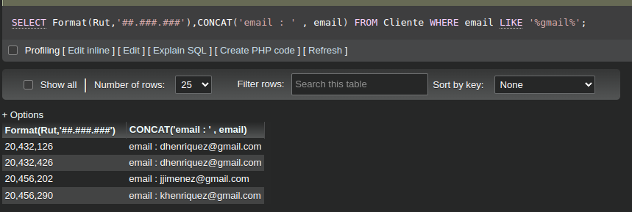

SELECT COUNT(DISTINCT Modelo) as 'Cantidad de modelos',

AVG(Precio),MAX(Precio),

SUM(Stock) as 'Zapatilla de mayor precio',

MIN(Precio) as 'Zapatilla de menor precio'

FROM `Zapatillas`

ORDER BY ProductID DESC;

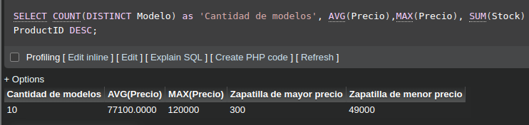

SELECT B.Rut,B.ProductID,Z.Modelo,B.ShopID,T.Nombre,B.CourrierID, C.Nombre FROM Boleta B INNER JOIN Zapatillas Z ON B.ProductID = Z.ProductID INNER JOIN Tienda T ON B.ShopID = T.ShopID INNER JOIN Courrier C ON B.CourrierID = C.CourrierID;

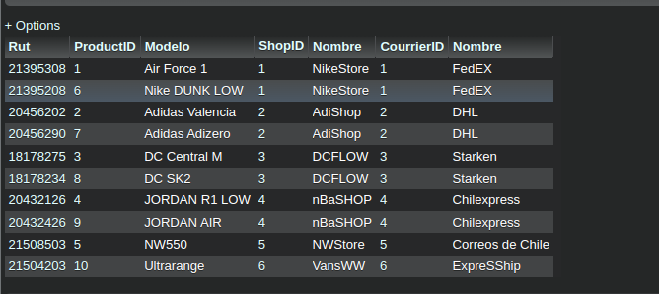

SELECT IDBoleta,Modelo,`Talla(Chile)`

FROM Boleta Bo LEFT JOIN Zapatillas Za ON Bo.IDBoleta = Za.ProductID;;

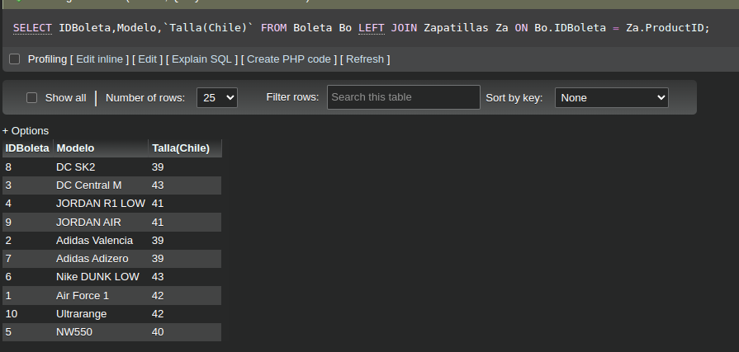

SELECT * FROM `Boleta` NATURAL JOIN Zapatillas;

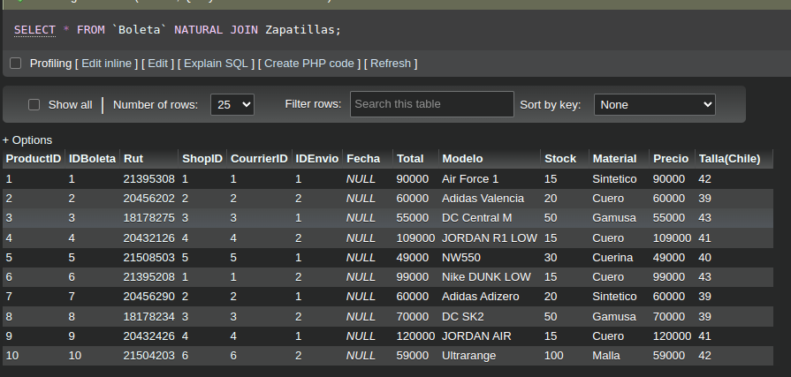

SELECT Material,

GROUP_CONCAT(Precio) as 'Precios',

GROUP_CONCAT(IDBoleta) as 'Boleta'

FROM Zapatillas

INNER JOIN Boleta ON Zapatillas.ProductID=Boleta.IDBoleta

GROUP BY Material;

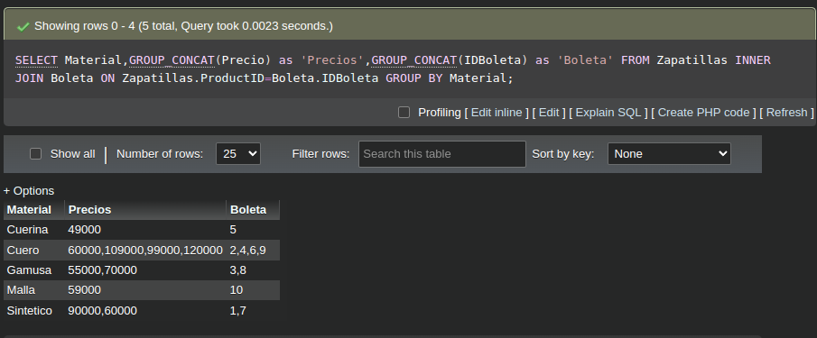

Select Format(Rut, '##.###.###'),CONCAT('email :', email) FROM Cliente WHERE email LIKE '%gmail%';

SELECT COUNT(DISTINCT Modelo) as 'Cantidad de modelos', AVG(Precio),MAX(Precio) as 'Precio maximo de una zapatilla Nike', SUM(Stock) as 'Stock Total Nike', MIN(Precio) as 'Precio minimo de una zapatilla Nike' FROM `Zapatillas` WHERE Modelo LIKE '%Nike%' ORDER BY ProductID DESC;

